Gaelic Literacy Support Ideas For at Home:

Games on Go Gaelic (help with grammar, vocab and sentence structure) – | 
Games on Gaelic4Parents (stage P5-7 - helps with grammar, vocab and sentence structure) - | 
Faclan cumanta 1-5 games (help with Gaelic common words) – QR codes and numbers attached separately. | 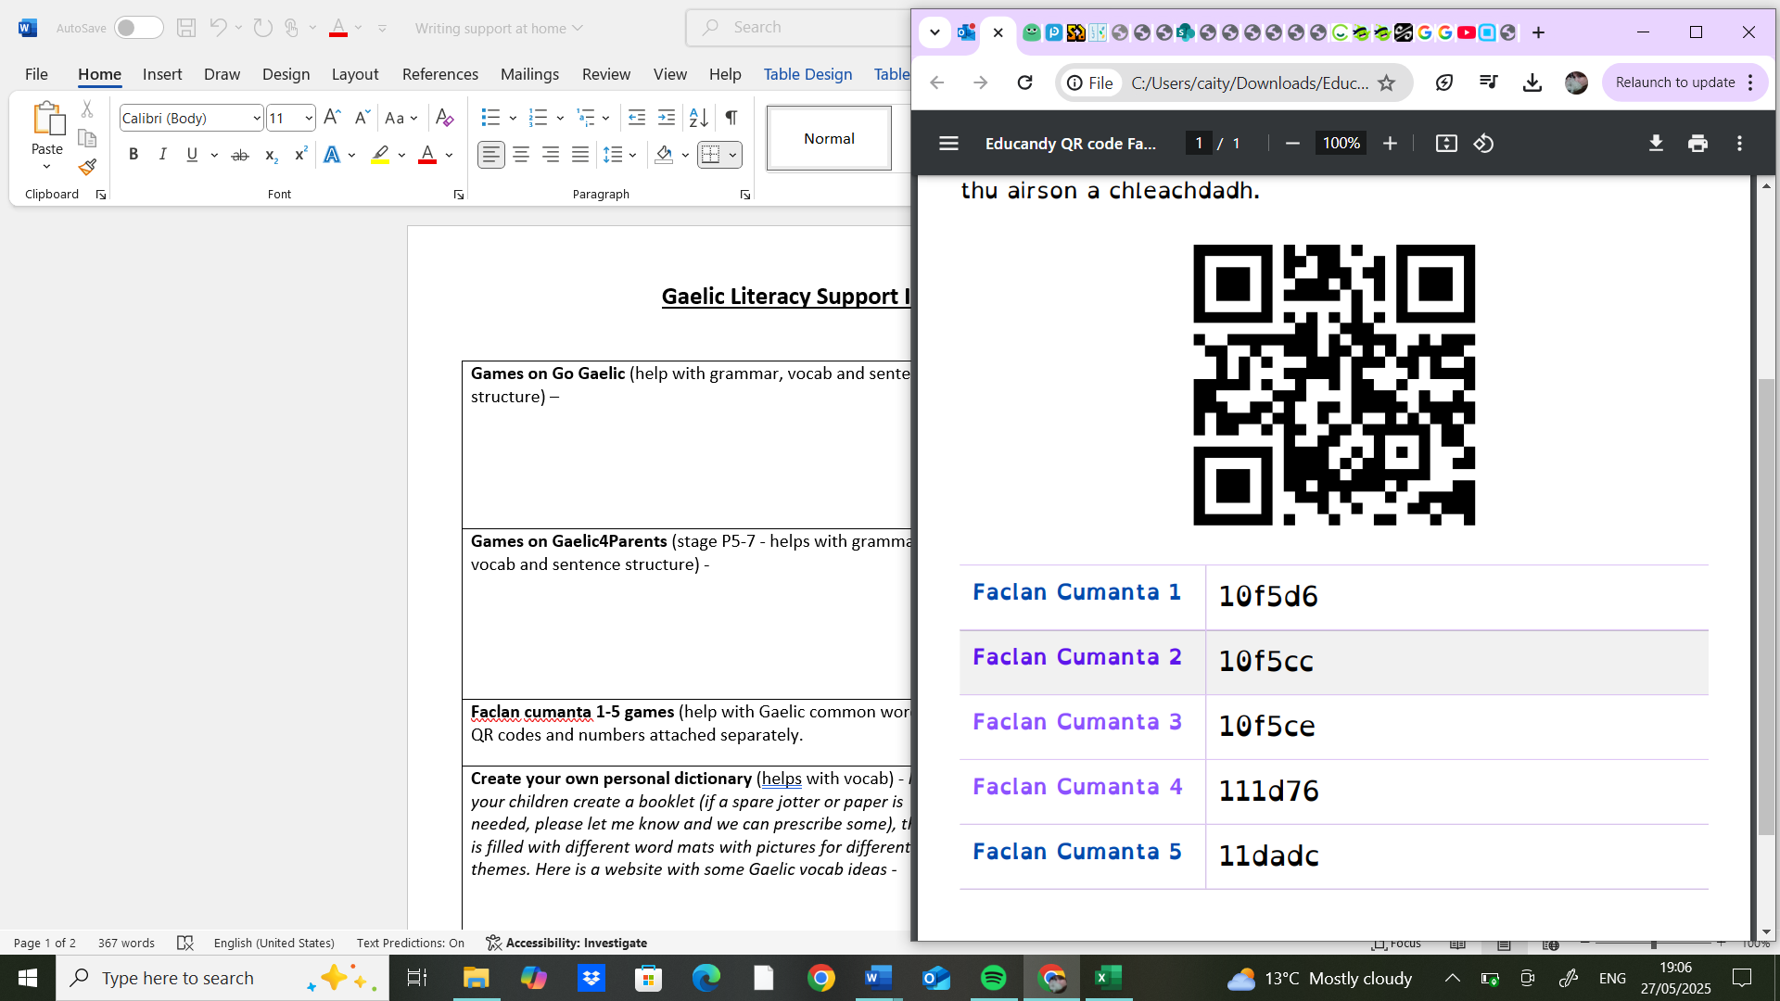
Create your own personal dictionary (helps with vocab) - Have your children create a booklet (if a spare jotter or paper is needed, please let me know and we can prescribe some), that is filled with different word mats with pictures for different themes. Here is a website with some Gaelic vocab ideas - | 
Watching programs in Gaelic on CBBC Alba/ YouTube page (helps with listening skills) - | 
FILMG – Watch the youth category films to see children their age speaking Gaidhlig in original sketches entered for the competition - | 
Creative Writing – Have children write and create their own creative story. It can be on anything they like, and they can add pictures, and make something they are proud of. There are loads of websites online to help prompt children if they don’t know where to start, or they can take inspiration from a picture. Children can use Google translate if needed to boost confidence (but try and encourage them not to), otherwise here are some great online dictionaries: | 
Gaelic WORDLE challenge (helps with spelling and vocab) - | 
BHLOGS – Get children to film their own short vlogs or silly sketches for fun in Gaidhlig, they can share these with school, or simply just for themselves for fun. | 
Be the teacher – Ask your children to teach you something simple, and let them be the teachers. Having children explain how something works in Gaidhlig will help solidify it for them too! Then can even make you a Kahoot quiz – we all love those! | 
Music – Have a look for some Gaidhlig songs and artist; some examples are Runrig and Manran but there are so much more, so have an explore! (whilst it’s Irish Gaelic and not Scottish Gaidhlig, I also can’t recommend this video enough, maybe the kids might even recognize some words too that are similar to our language - | 

Maths Support Ideas For at Home:
Addition: Cur-ris/ Subtraction: Toirt air falbh  Physical practice: Card games using deck of cards, dice games, lego towers,  Digital Practice: Maths frame, Top Marks, Khan Academy, BBC, Sumdog  Supports: Number lines, 10 frames | Multiplication: Uiread/ Division: Roinn  Physical practice: Cooking/ adjusting recipes, dice and card games, sharing piles of items, multiplication stories, arrays  Digital Practice: Maths frame, Top Marks, Khan Academy, BBC, Sumdog  Supports: Multiplication square
Money: Airgead  Physical practice: Helping at the shops, handling physical change, savings challenges, budgeting, monopoly,  Digital Practice: Maths frame, Top Marks, Khan Academy, BBC, Sumdog, teaching money,  Supports: Money Heroes | Time: Uair  Physical practice: Timing sports activities, setting alarms, planning routines, ticket to ride  Digital Practice: Maths frame, Top Marks, Khan Academy, BBC, Sumdog, teaching time  Supports: Clocks with numbers around the outside, calendar, counting in 5’s
Measurement: Tomhais  Physical practice: Cooking and baking, gardening, height and foot size measurement, measuring spaces for things, furniture construction  Digital Practice: Maths frame, Top Marks, Khan Academy, BBC, Sumdog, mathnook  Supports: Rulers, tape measures, scales, measuring cups | Angles/ Directions: Ceàrnan / Stiùiridhean  Physical practice: Finding perfect right angles, angles in nature photography, orienteering, scavenger hunts  Digital Practice: Maths frame, Top Marks, Khan Academy, BBC, Sumdog, google maps, nrich, online compass  Supports: Protractors, compass, maps
Shape: Cumaidh  Physical practice: playdough, nets, drawing, architecture  Digital Practice: Maths frame, Top Marks, Khan Academy, BBC, Sumdog, ABCYa  Supports: Picture dictionary | Fractions: Bloighean  Physical practice: Cutting food or other things, fraction Pictionary, fraction hopscotch  Digital Practice: Maths frame, Top Marks, Khan Academy, BBC, Sumdog, Maths playground  Supports: Fraction circle/ bars, paper plates, lego bricks
Data handling: Làimhseachadh dàta  Physical practice: Spreadsheets, creating different kinds of graphs, conducting surveys, looking at timetables and real-life data,  Digital Practice: Maths frame, Top Marks, Khan Academy, BBC, Sumdog, Excel,  Supports: Pictograms | Problem solving: Fuasgladh Cheistean  Physical practice: Jigsaws, mazes, egg drop, limited material challenges, detective mysteries, noughts and crosses, riddles  Digital Practice: Maths frame, Top Marks, Khan Academy, BBC, Sumdog, BRIGHT SIDE  Supports: Visualizing/ drawing, chunking

